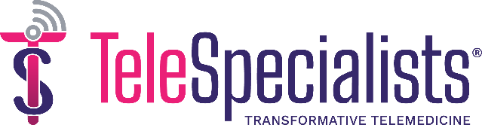
Stroke Awareness Month Media Release
[Hospital Name] Prioritizes Stroke Care with TeleSpecialists During Stroke Awareness Month
[Hospital Name] emphasizes stroke care and improved patient outcomes through collaboration with industry-leading telestroke leader during Stroke Awareness Month
[Hospital Name] is supporting National Stroke Awareness Month by partnering with TeleSpecialists’ industry-leading TeleStroke program, providing stroke treatment and improving patient outcomes. National Stroke Awareness Month, recognized every May, aims to raise public awareness about stroke risk factors to lessen the occurrence of stroke in the country. In addition to their stroke program, [Hospital Name] will provide informational stroke resources in conjunction with TeleSpecialists throughout the month to patients and their local community.
“Stroke Awareness Month is very important to us, and together with TeleSpecialists, we’re making it our mission to provide the best stroke treatment and share knowledge about strokes to ultimately save lives,” said [Hospital Official Name, Title]. “We strive to keep our community informed so they can be prepared should they or someone they know experience a stroke and know they’re in good hands when they arrive at our hospital.”
[Hospital Name]’s stroke program excels with the implementation of TeleStroke, which provides patients 24/7/365 emergency access to board-certified neurologists with extensive experience treating strokes. Patients arriving at the hospital are met with a neurologist on-screen within an average of three minutes of a consult request so treatment can begin immediately. The faster a patient receives treatment for a stroke, the more brain cells are saved, which increases the chances of recovery.
OPTIONAL: To date, [Hospital Name] has used the TeleStroke service for more than XXX stroke and inpatient consultations. On average, [Hospital Name] treats more than XXX stroke patients annually.
In addition to providing quality, timely care to their stroke patients, [Hospital Name] is also sharing resources about the signs and symptoms of a stroke. These resources include videos from TeleSpecialists neurologists about lifestyle after stroke and the impact of stroke, informational social media content, and the SAVES and BEFAST acronyms for stroke signs and symptoms.
About TeleSpecialists
TeleSpecialists® is the leading national physician-owned provider of telemedicine solutions for quality-focused hospitals and healthcare systems that sets the standard for rapidly accessible remote neurology and psychiatry services, both emergent and non-emergent.
Our board-certified physicians deliver better patient outcomes and save lives through transformative, quality care.

###

